# Properties of an array

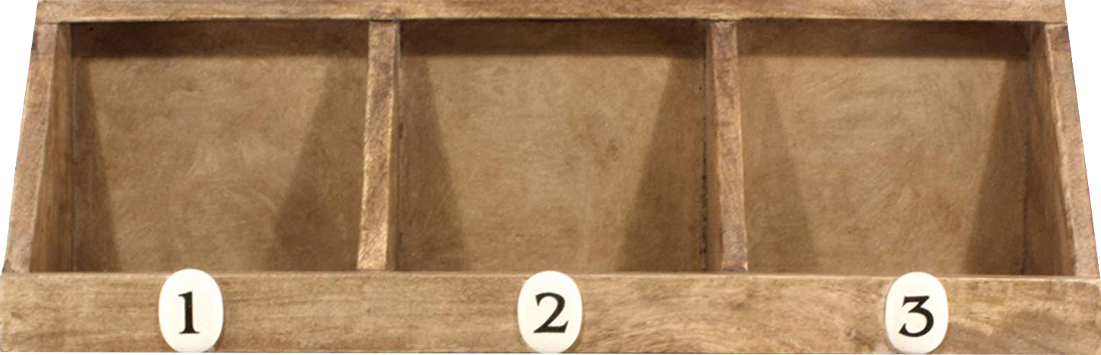

Some important terminology:

* An **element** is an item of an array, for example, a tea cup is an element of cupboard.
* An **index** is the numbered slot where an element is stored, for example, the numbers on the pigeon holes in the image above are indexes.

Arrays have a few important properties:

1. An array is **fixed in size** for the entire life of the program, this means its size must be specified using a constant (a literal such as 10 or a variable declared as const).
2. All of the elements of an array are the **same data type**, you can't put a string in an array of int.
3. The elements of an array are **ordered** and **indexed**, this means you can directly ask an array for its second element and you will always get the same response until that element is modified.

Interesting fact: In the computer, the elements of an array are stored in a **contiguous (no gaps)** block of memory. That's important because it makes indexing arrays possible, when all of the elements are the same data type and there is no space between elements it is easy for the computer to find the location of any element in memory just by its index.